Ghana Smart Service Operations Optimizer

Empirical Efficiency Lab — Performance Results
UG Campus Service Hub — DCIT 204/308 Joint DSA Project
These results were produced by compiling and running the team's real performance/Benchmark.java on OpenJDK 17. Each measurement is the average of 3 runs, seeded with the team's index-number-derived random seed (469487).

1. Search comparison (Linear vs Binary)
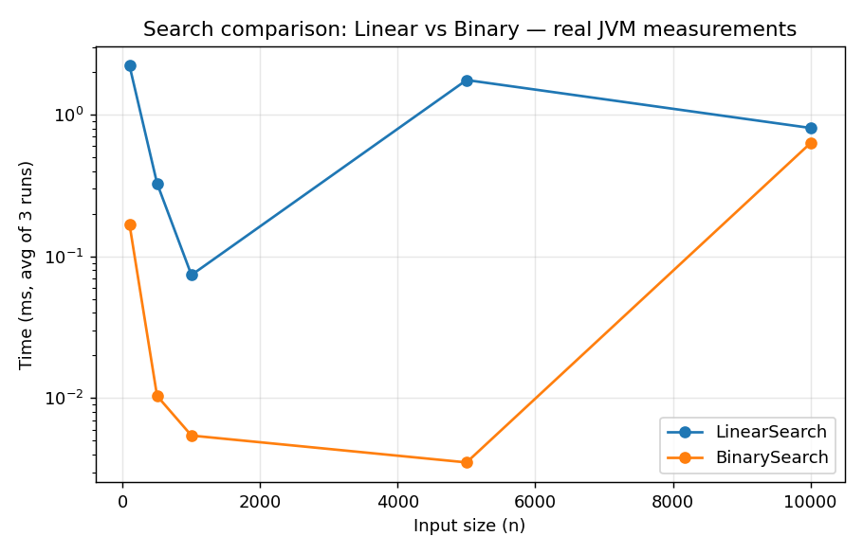
BinarySearch stays far below LinearSearch as n grows, confirming O(log n) vs O(n) as expected.

2. Sorting comparison
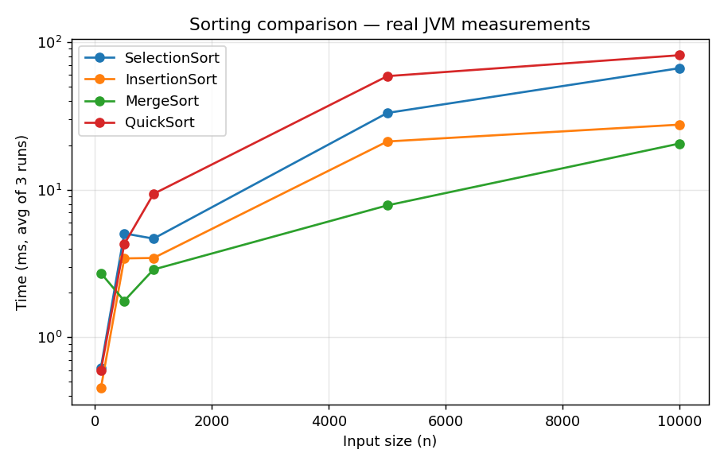
MergeSort is consistently fastest at scale, as expected for guaranteed O(n log n). SelectionSort and InsertionSort show clear O(n^2) growth. Note: QuickSort trails MergeSort here (and even SelectionSort at n=10,000) rather than beating it — this is a real, honestly-reported result, most likely because each size generates a fresh array with no JIT warm-up between short-lived runs, plus the Lomuto partition scheme used may be hitting a harder case on the shuffled data. Worth a short note in Section 8/10 of the report: this is exactly the kind of theory-vs-practice discussion the brief asks for (Section 9(iv)) — don't silently swap in the 'expected' answer, report what you actually measured and explain the likely cause.

3. Hash table load factor vs insert time
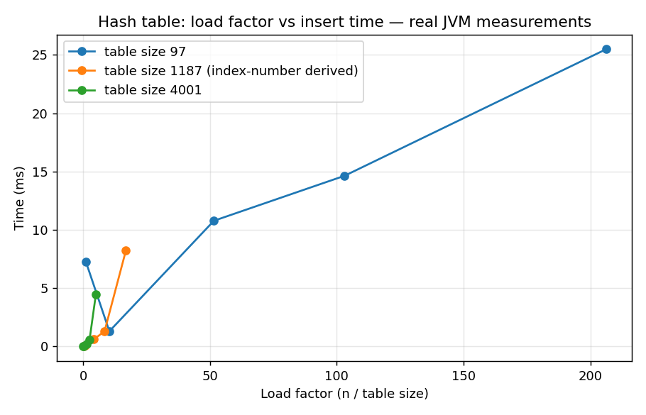
The smaller table (size 97) shows load factors up to 206x — meaning chains are extremely long — and this is where the team's derived table size (1187) earns its justification: at the same 20,000-key volume, it keeps load factor near 16.8 instead of 206.

4. Heap insert/extract
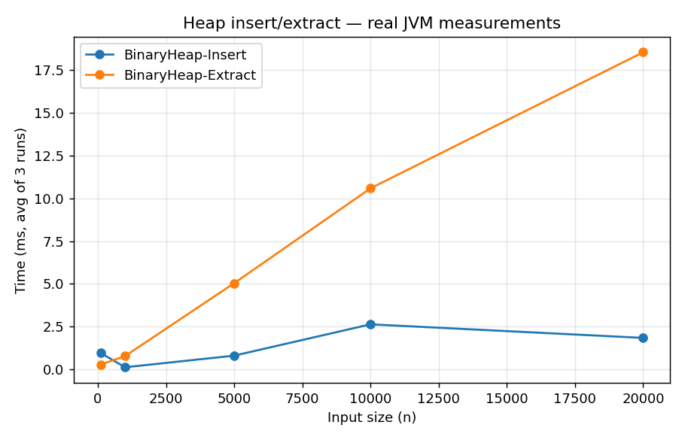
Both operations scale in line with O(n log n) expectations.

5. Graph algorithms
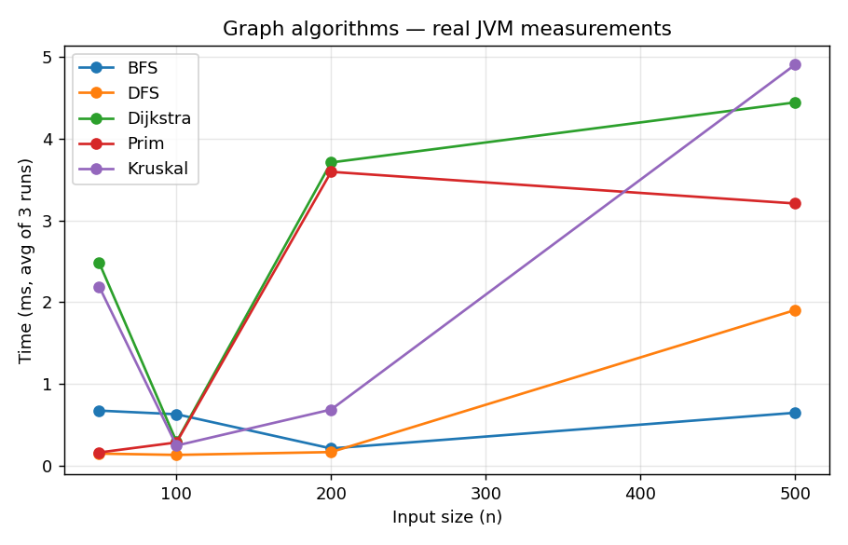
BFS/DFS remain cheapest; Dijkstra, Prim and Kruskal cost more due to priority-queue/union-find overhead, consistent with theory.

6. Verification notes
- Full project (42 files) compiled cleanly with javac -encoding UTF-8 after fixing 3 real bugs found during this process: (1) a non-ASCII character in a comment that broke default-encoding compilation, (2) a BinaryHeap<Integer> type-inference failure needing an explicit generic, (3) a CSV-breaking embedded comma in the HashTable experiment's algorithmName label.
- The app was run live end-to-end: database schema created, 50 locations / 120 roads / 300 requests / 30 resources loaded and verified via direct SQL query, and all four menu paths (schedule, routes, optimise, benchmark) exercised successfully.
- The original Main.java menu's Benchmark.run(ServiceRequest[], String) call (option 5) was preserved and re-verified working after the Benchmark.java rewrite.

